NIST SP 800-171 Compliance for Log360
Strengthen cybersecurity and meet NIST SP 800-171 compliance with Log360.
Region: USA | Type: Government/Public Sector, Industry Standard, Incident Management | Category: Compliance | Pricing: Free

Overview
The NIST SP 800-171 compliance extension in Log360 helps organizations meet NIST SP 800-171: Protecting Controlled Unclassified Information in Nonfederal Systems, a federal security standard mandating 17 control families for DoD contractors and organizations processing CUI by providing centralized log management, user activity monitoring, and advanced threat detection. The platform supports NIST SP 800-171 requirements for access control, audit and accountability, identification and authentication, incident response, configuration management, privileged access governance, and risk assessment.
For Access Control for CUI, Log360 monitors Windows and Unix logon activities, failed access attempts, AD logon events, and terminal service sessions to enforce least-privilege access and detect unauthorized CUI access. To address Audit and Accountability for CUI Systems, the platform collects event logs, system events, process tracking, and GPO audit records to maintain the comprehensive audit trail required for CUI accountability. The extension also supports Identification and Authentication of CUI Users by providing capabilities that monitors password management, MFA logon activity, Entra ID risky sign-ins, and user logon patterns to enforce strong authentication and detect compromised credentials in CUI environments.

Key Features
- Incident Response for CUI Breaches: Log360 monitors network attacks, malware events, Windows and Unix threat detections, and firewall violations to enable rapid CUI breach detection and response.
- Configuration and System Integrity Management: Log360 audits network device configurations, policy changes, registry modifications, and application whitelisting to maintain system integrity.
- Privileged Access and Personnel Security: Log360 monitors Unix account management, SUDO usage, group changes, Entra ID role assignments, and password auditing to enforce least-privilege principles for CUI system administrators.
- Media Protection and CUI Data Integrity: Log360 audits removable disk usage, USB storage events, file system modifications, and registry changes to protect CUI stored on portable and fixed media.
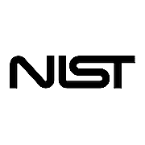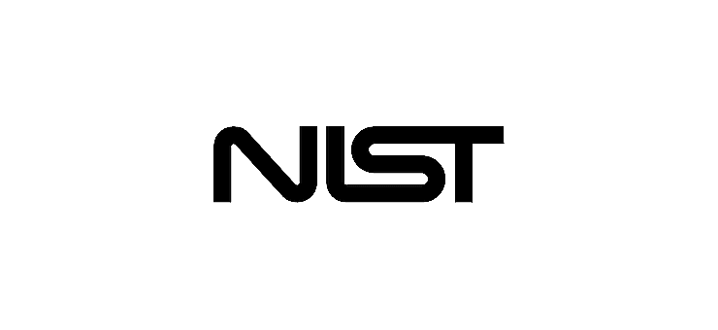

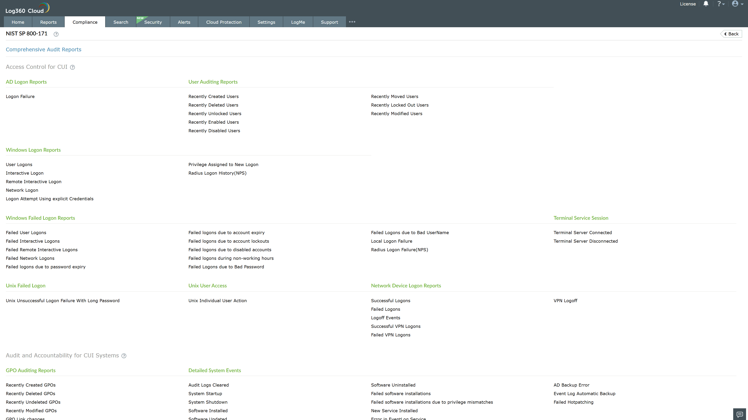
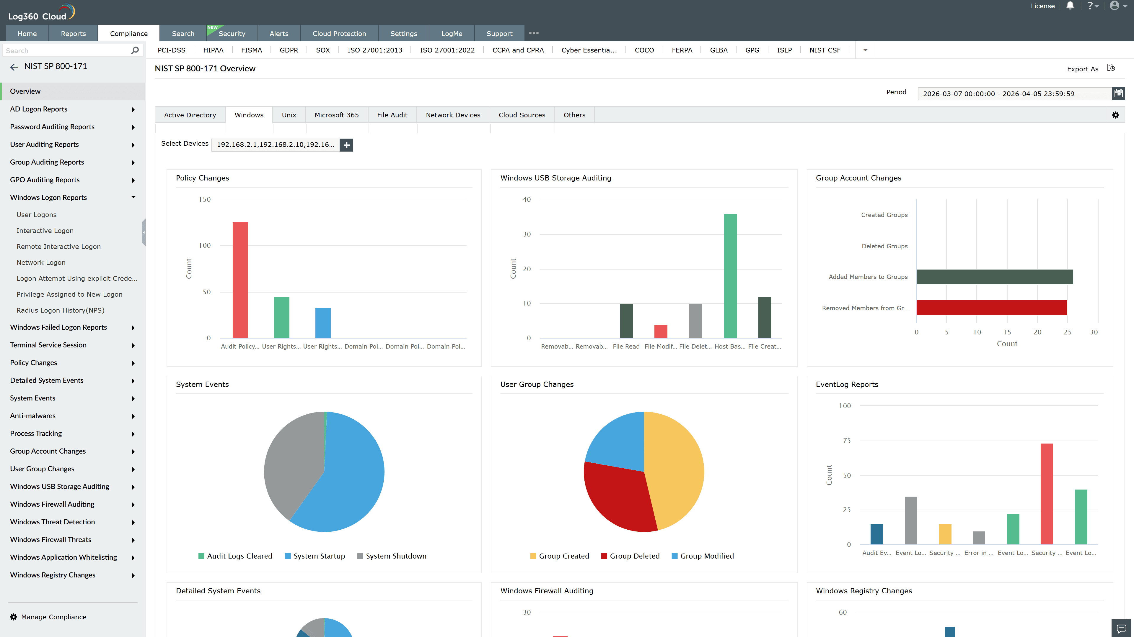
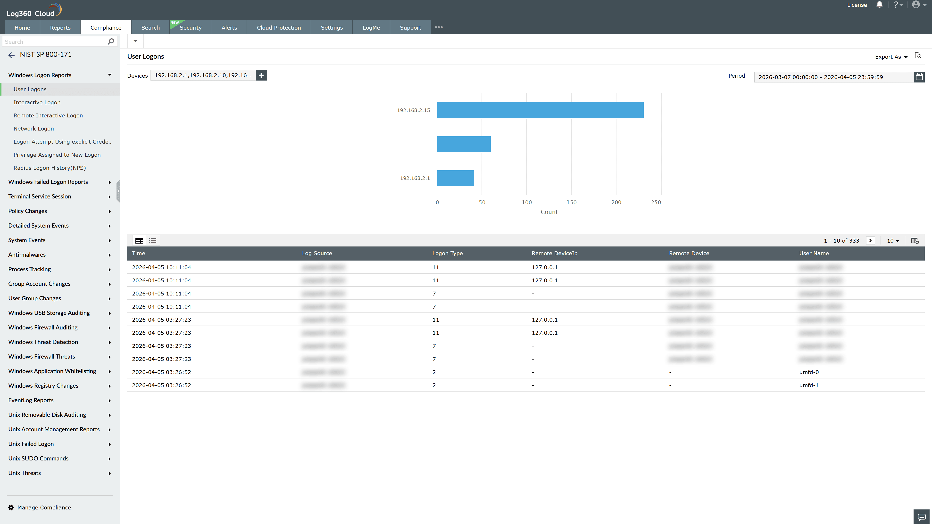
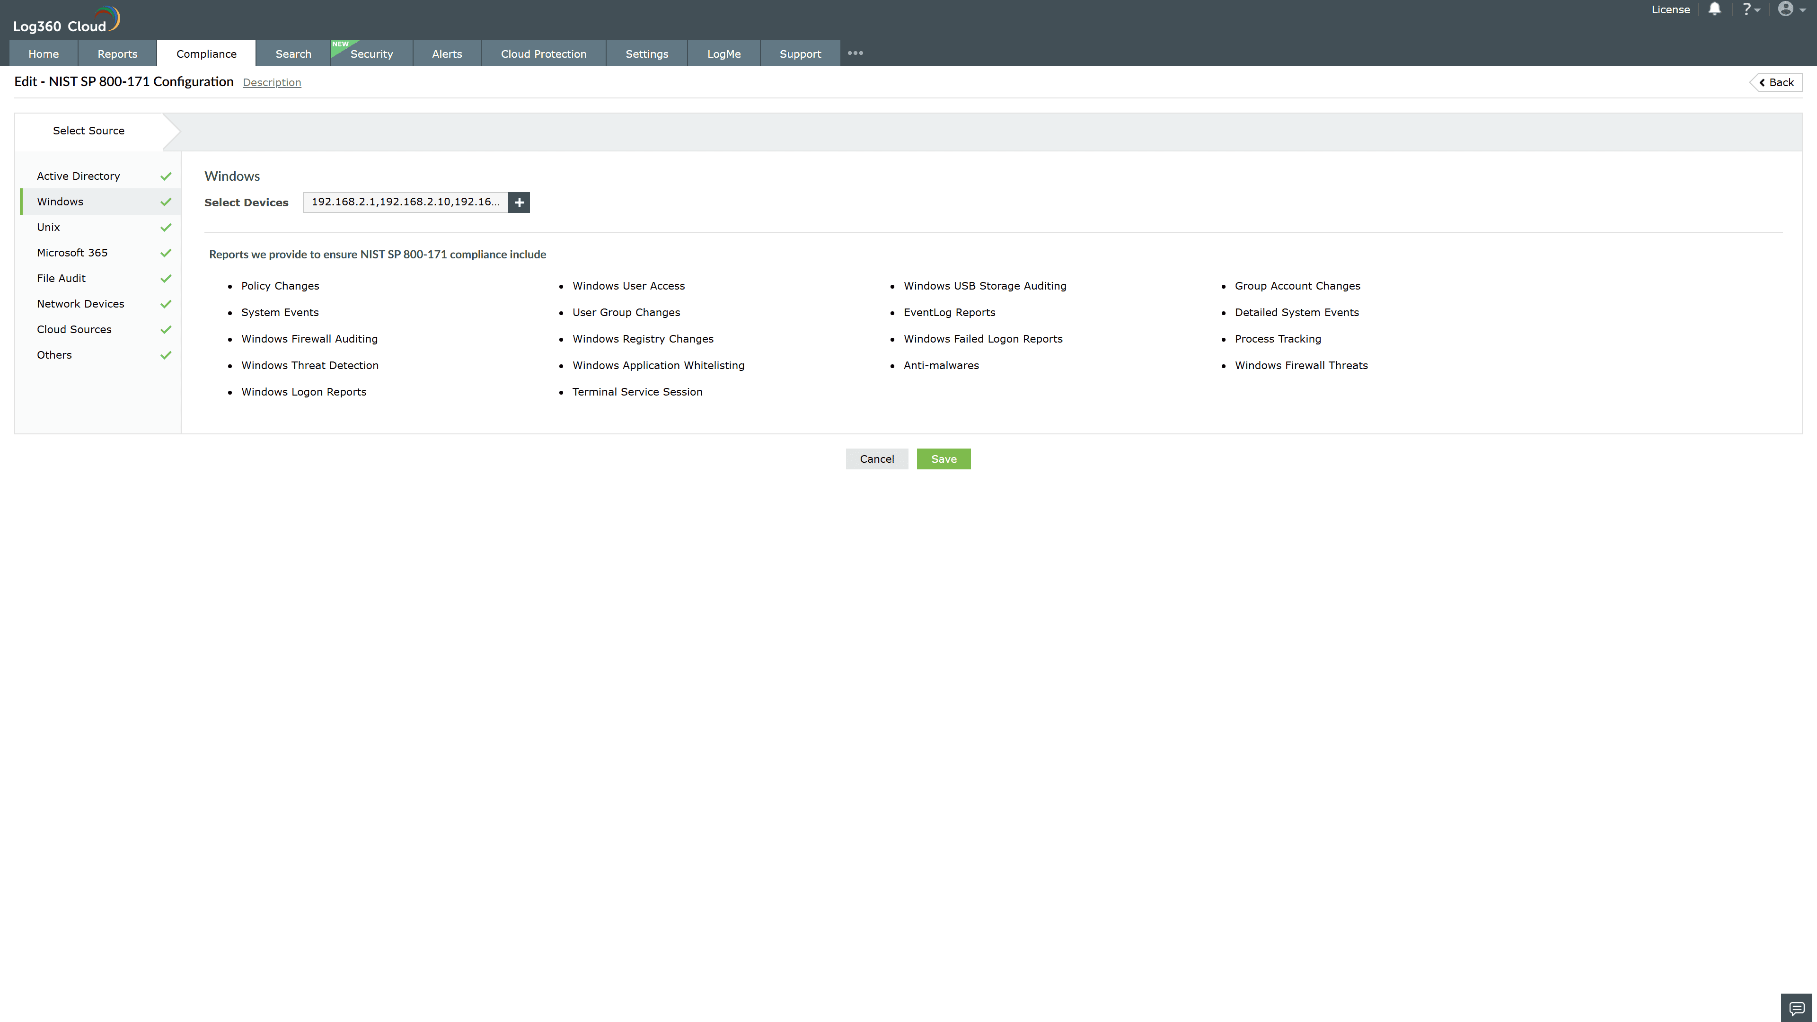
Valid Submission : Yes
Supported Editions : Free, Basic, Standard, Professional, MSSP
Help Document : https://www.manageengine.com/log-management/help/integrations/compliance-extensions.html
Help Video : Not provided
Tags : Log360, Compliance, Privacy monitoring, Data privacy, Regulatory compliance
Supported DCs : US, IN, JP, CA, AU, UK and EU
Privacy Policy:
Terms of Service:
Release Notes:
Predefined reports for the NIST SP 800-171.

